V-Series Veterinary Endoscope
Operation Manual
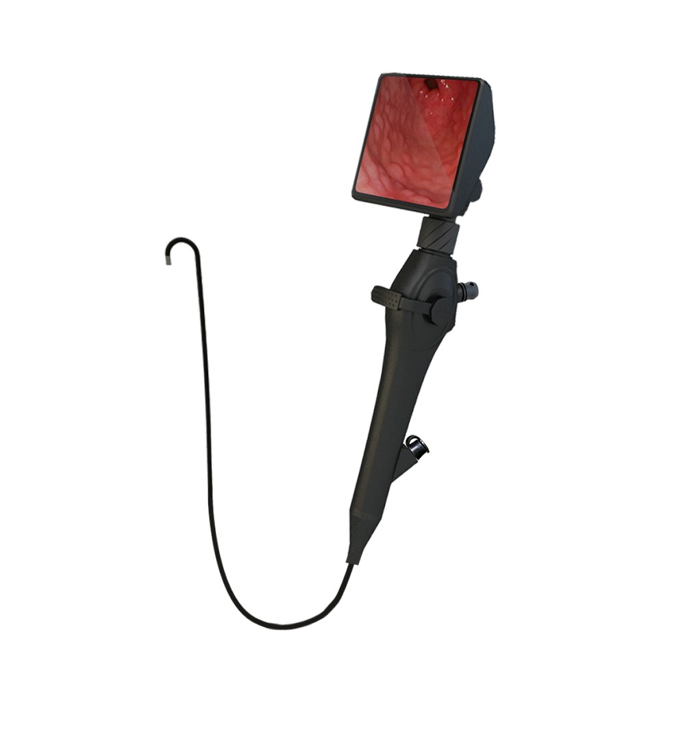

1. Product Introduction
1.1 Indication for Use
The product is intended for use as below:
- Aid in endotracheal intubation.
- For ENT observation.
- Teaching purposes.
- Protective intubating from patient.

1.2 Contraindications
The product is not recommended for use in patient with following:
- Foreign body is in the airway.
- Needs for emergency intubation.

2. Description
The whole set consists of the following main parts:
- Outer diameter:
□ 2.8 mm
□ 3.8 mm / 1.2mm
□ 4.8 mm / 2.2mm
□ 5.2 mm / 2.4mm
□ 5.8 mm / 2.6mm
- Length: 60cm.
- Material: Aluminum alloy / Medical grade plastic
- Light source: White LED, brightness ≥ 3000 LUX.
- Camera: 160,000 pixels/ 400 x 400.
- Display: 4.0” LCD. 480*480
- Waterproof IP Rating: IPX4.
- Photos, video recording, and record storage.
- Rotation angle: (horizontal) ≥100°/ (vertically) ≥120°.
- Built-in 16G memory card.
- Battery specifications: 3.3V ± 10% lithium 2000mAh.
- Power supply: Input AC 100V~240V /
Output DC 5V, 1A

3. Before use

3-1 Unpacking
Take out all items from the case, and carry out the following:
- Check if there are any parts missing. (See Table 1).
- Inspect parts for damage.
- Report damage or shortage to the local distributor, if any.
Table1
List of Accessories
Item | Description | Quantity
Case | Metal case | 1
Rechargeable Screen | 4.0’’ LCD Screen | 1
Flexible Video Intubation Stylet | Handle with flexible built-in camera | 1
Power supply cable | power supply cable | 1

3-2 Charging
- Plug the power cord into the USB port on the side of the screen. (Fig. 1).
- Blue light indicator means charging.
- The green light turns on when fully charged. 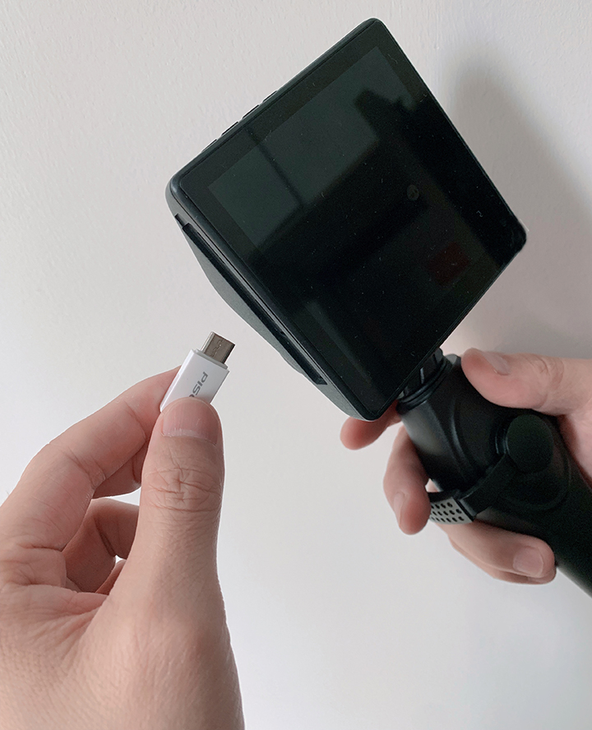 Fig.1

3-3 Installation
- Connect the flexible intubation stylet with the screen, and ensure groove alignment (Fig. 2).
- Lock the flexible intubation stylet with spiral ring (Fig.3).
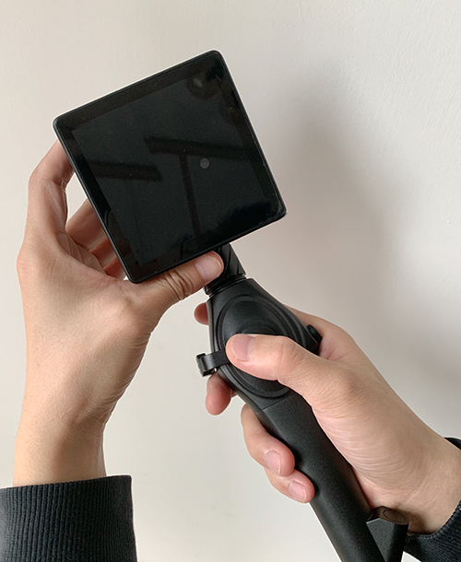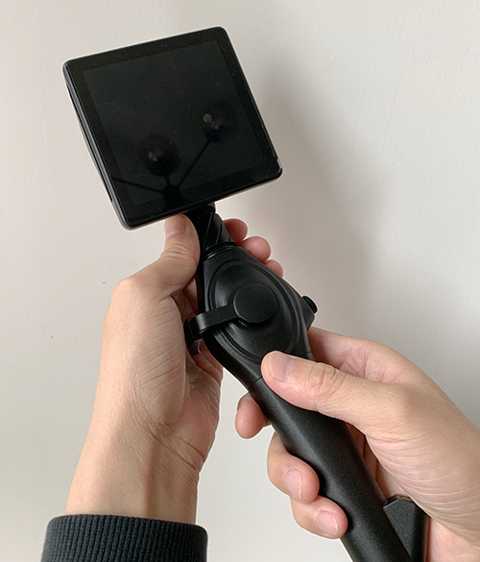
Fig 2 Fig 3

3-4 Function test
- Power button: Power on/off (one second: on/two seconds: off).
-  Up and Down button: Confirm the option.
-  Setting Button: Menu mode
-  Photo/Video recording button on the handle:
1). One click to take photo
2). Press and hold to record
3). One click again to stop recording

3-5 Setting
After Press Setting button, you will see the Screen on the following:
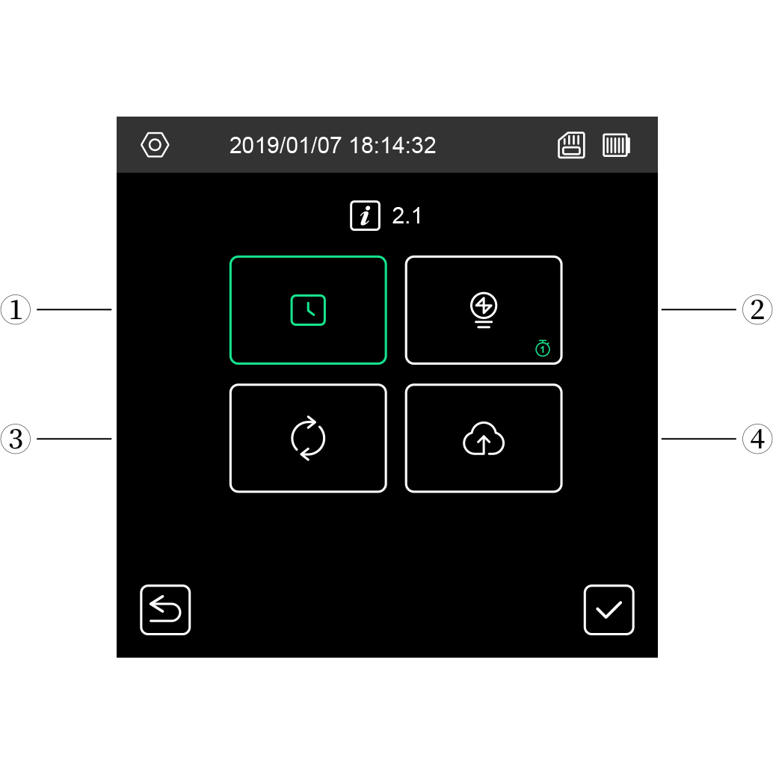

Time Setting: select the up/down button and setting button to set the right time
Auto Shut Down: you can select the time 1minute, 3 minutes, 5 minutes Automatic shut down when the device without operation
File Formatting
Caution: please save your file before you selected this function.
FW updated: You can use this function when update the system

3-6 Menu and Function
When the device is on ad you touch the screen, you will see the following:
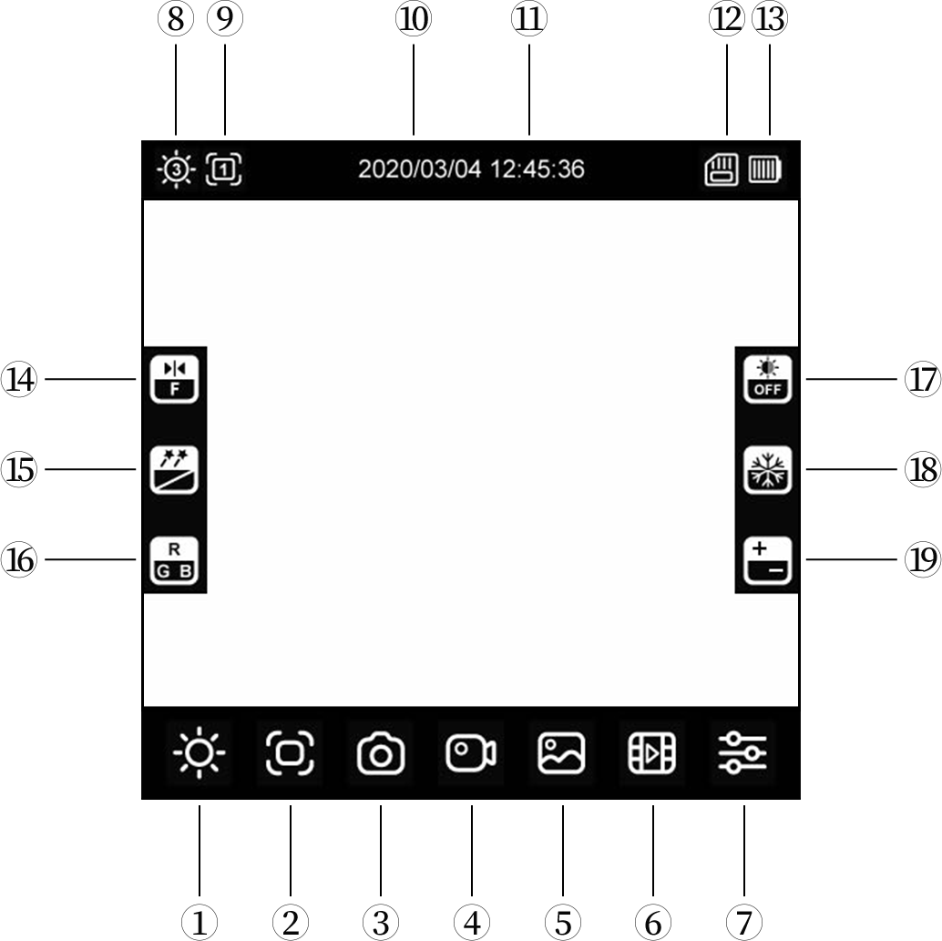
①.Lightness Adjusting: Touch icon to adjust the lightness by referring the level from
②.Zoom: touch the icon and zoom by referring the level from
③.Photo Shooting
④.Video Recording
⑤. Image Review
⑥. Video Review
⑦. Setting Icon: Same as setting button
⑧. Lightness states
⑨. Zoom states
⑩/⑪. Date/time
⑫. SD Card
⑬. Battery
⑭. Image mirror
⑮. Image effect
⑯. RGB regulation
⑰. White balance
⑱. Image freeze
⑲. Flashilghting

4. Operating Instructions
Fig.9-11
Connect the flexible video intubation stylet and the screen, and then lubricate the stylet. (Fig. 4)
Insert the flexible stylet from the oral cavity or nasal cavity slowly and observe the condition. (Fig.5)

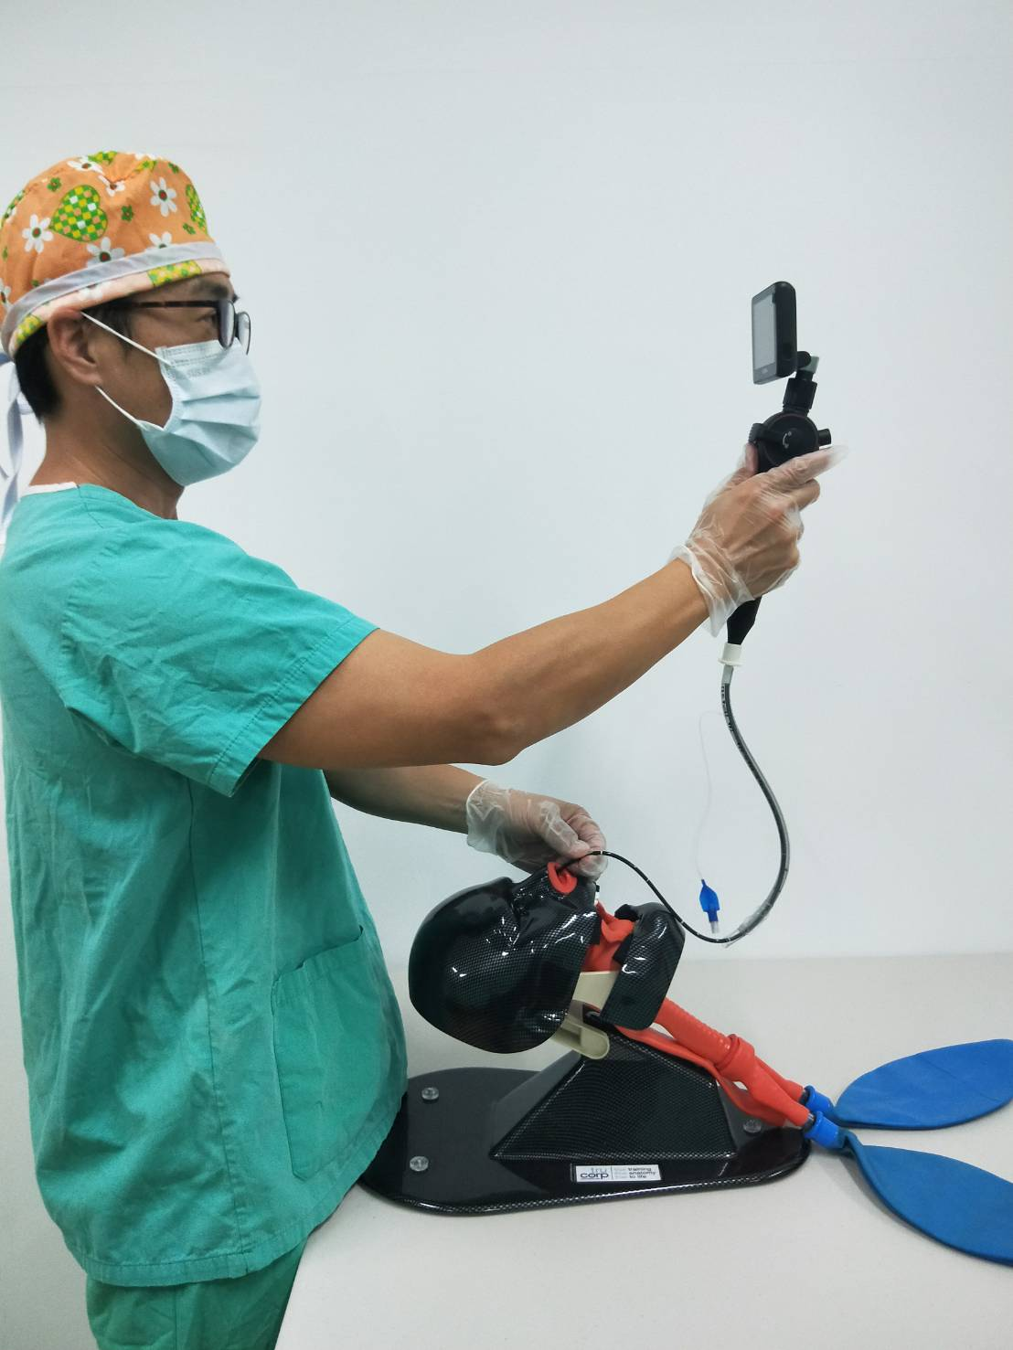
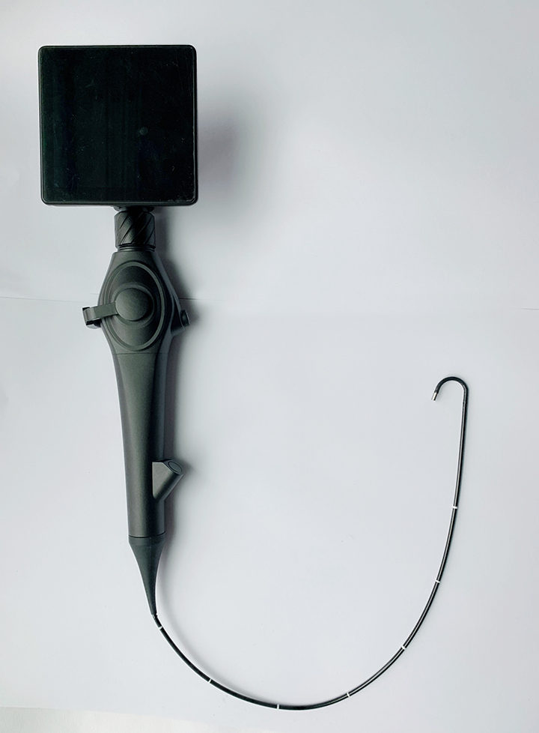
Fig.5

Fig. 4

When the epiglottis appears on the screen, adjust the angle of the flexible stylet and then advance the stylet through the vocal cords. (Fig. 6 & 7)
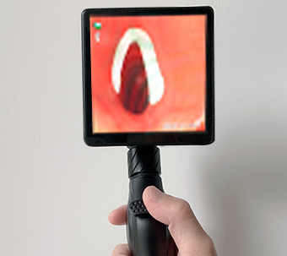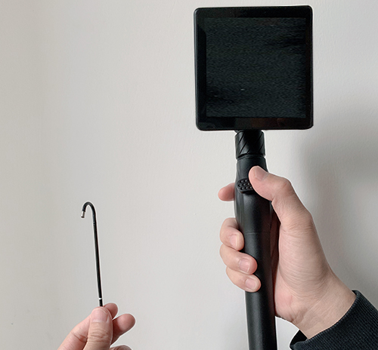
Fig. 6 Fig.7

Observe the condition on the screen, and insert the endotracheal tube. (Fig. 8 & 9)

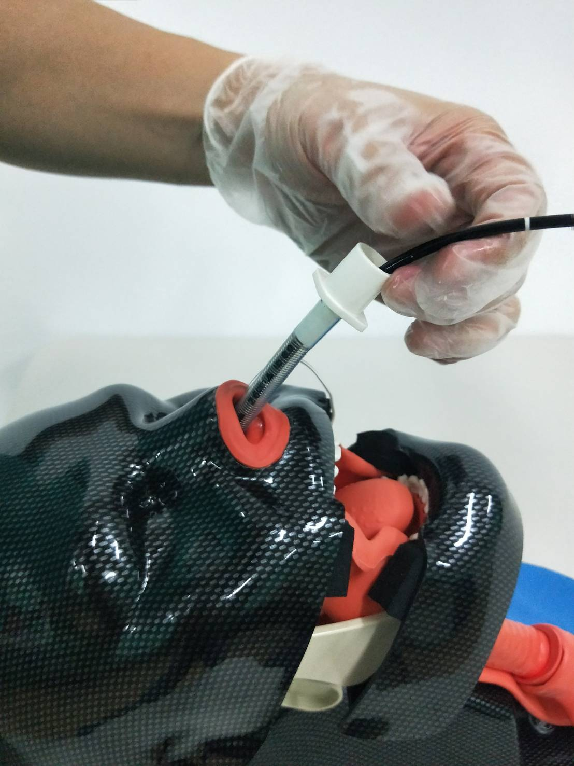
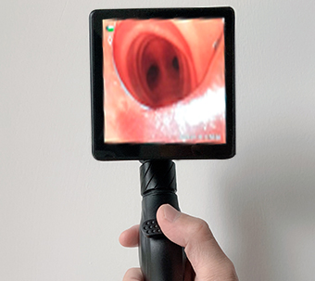
Fig. 9
Fig. 8

5. Cleaning and Disinfection
Method | Flexible video intubation stylet
Wipe with a gauze pad with 75% alcohol | O
Enzymatic Cleaning Solution | O
Glutaraldehyde 2% solution - Cidex | O
Ethylene Oxide Gas (E.O.) | X
Autoclave | X

6. Service
There is no user serviceable parts inside the qualified screen handle, which
has passed performance tests and quality assurance tests and meet qualification criteria prior to shipment. No calibration is required, and please do not open any
part of the products. We will be held responsible for damage only when service, repair, readjustment or modification needs to be carried out by us or any personnel authorized by us.

7. Troubleshooting
Problem | Cause | Solution
Rechargeable Screen Handle failure | Battery level low | Charging
Rechargeable Screen Handle failure | Oxidation of contact surfaces | Clean the contact
Rechargeable Screen Handle failure | Poor contact between Stylet/laryngoscope and handle | Tighten both parts
Data transfer failure | Loose connection | Check whether the cable’s firmly connected.
Blurred image | Len stains | Clean the lens

Important: After trying all above solutions but the problems remain, please
contact the local distributor.

8. Specification
显示器部 | 显示屏 | 4 寸IPS全视角显示屏
显示器部 | 显示屏分辨率 | 480*480
显示器部 | 操作界面 | 电容触控与按键双套并存操作
显示器部 | 图像控制 | 连续 (4倍)
显示器部 | 图片格式 | JPEG/JPG
显示器部 | 软件升级 | 可通过TF卡升级
显示器部 | 视频格式 | AVI
显示器部 | 功能 | 拍照、录像、亮度调节、画面冻结
显示器部 | 文件管理 | 图片/视频播放、删除、格式化
显示器部 | 内存 | 16G最大扩展32G SD卡
显示器部 | 数据I/O端口 | SD卡、HDMI视频信号、USB
显示器部 | 电池工作时间 | 6h
显示器部 | 亮度调节 | 6级亮度调节
操作部 | 摄像头像素 | 30W数字成像
操作部 | 插入管可选配 | （直径） | (通道)
操作部 | 插入管可选配 | 2.8mm / 无
操作部 | 插入管可选配 | 3.8mm / 1.2mm
操作部 | 插入管可选配 | 4.8mm / 2.2mm
操作部 | 插入管可选配 | 5.2mm / 2.4mm
操作部 | 插入管可选配 | 5.8mm / 2.6mm
操作部 | 插入管镜头视角 | 两方向可调节
操作部 | 异物（取样）钳 | 700mm/1200mm（可选）

8. General Information
8-1 Safety Standards
Safety requirements
Meets the requirements of GB9706.1-2007 and GB9706.19-2000

Electromagnetic compatibility (EMC)
Meets the requirements of YY0505-2012 and GB9706.19-2000.

Environmental requirements
Meet the requirements of climatic environmental test group II, mechanical environmental test group II, transportation test and adaptability to power supply.

8-2 Operation/storage/transport conditions
Operating conditions
Ambient temperature: -5ºC ~ 40ºC
Relative humidity: ≤80% (no condensing)
Atmospheric pressure: 700hPa ~ 1060hPa
Never place it in direct sunlight or near any other source of cold or heat.

Storage and transportation conditions
Ambient temperature: -20 ° C ~ +55 ° C
Relative humidity: ≤93%

9-4 Annex
Annex: 1
Guidance and manufacturer’s declaration ---electromagnetic emissions
Video intubation set is intended for use in the electromagnetic environment specified below. The customer or the user of the device should assure that the device is used in such an environment.
Emissions test | Compliance | Electromagnetic environment--guidance
RF emissions  GB 4824 | Group 1 | Video intubation set uses RF energy only for its internal function. Therefore, its RF emissions are very low and are not likely to cause any interference in nearby electronic equipment.
RF emissions  GB 4824 | Class A | Video intubation set can be applied with all establishments other than domestic and those directly connected to a low voltage power supply network which supplies buildings used for domestic purposes.
Harmonic Emissions  GB 17625.1 | NA
Voltage Fluctuations/Flicker Emissions  GB 17625.2 | NA

Annex: 2
Guidance and manufacturer’s declaration—electromagnetic immunity
Video Intubation Set is intended for use in the electromagnetic environment specified below. The customer or the user of the device should assure that the device is used in such an environment.
Immunity Test | IEC 60601 Test level | Compliance level | Electromagnetic environment-guidance
Electrostatic discharge  GB/T 17626.2 | ±6 kV contact  ±8 kV air | ±6 kV contact  ±8 kV air | Floors should be wood, concrete or ceramic tile. If floors are covered with synthetic material, the relative humidity should be at least 30%.
Electrical fast transient/burst  GB/T 17626.4 | ±2kV for power supply lines  ±1kV for input/output lines | NA | Mains power quality should be that of a typical commercial or hospital environment.
Surge  GB/T 17626.5 | ±1 kV differential mode  ±2 kV common mode | NA | Mains power quality should be that of a typical commercial or hospital environment.

Annex: 2
Guidance and manufacturer’s declaration—electromagnetic immunity
Video Intubation Set is intended for use in the electromagnetic environment specified below. The customer or the user of the device should assure that the device is used in such an nvironment.
Immunity Test | IEC 60601 Test level | Compliance level | Electromagnetic environment-guidance
Voltage dips, short interruptions and voltage variations on power supply input lines  GB/T 17626.11 | <5 % U_{T} (>95% dip in U_{T}) for 0.5 cycle  40 % U_{T} (60% dip in U_{T}) for 5 cycles  70 % U_{T} (30% dip in U_{T}) for 25 cycles  <5 % U_{T} (>95% dip in U_{T}) for 5 sec | NA | Mains power quality should be that of a typical commercial or hospital environment.  If the user of the device requires continued operation during power mains interruptions, it is recommended that the device be powered from an uninterruptible power supply or a backup battery system.
Power frequency  （50/60Hz）  GB/T 17626.8 | 3A/m | 3A/m | Power frequency magnetic fields should be at levels characteristic of a typical location in a typical commercial or hospital environment.
Note: U_{T} is the AC mains voltage prior to application of the test level.

Annex: 3
Guidance and manufacturer’s declaration—electromagnetic immunity
Video Intubation Set is intended for use in the electromagnetic environment specified below. The customer or the user of the device should assure that the device is used in such an environment.
Immunity Test | IEC 60601 Test level | Compliance level | Electromagnetic environment-guidance
Conducted RF  GB/T 17626.6  Radiated RF  GB/T 17626.3 | 3 V(Effective value)  150 kHz～80 MHz  3 V/m  80 MHz～2.5 GHz | NA  3 V/m | Portable and mobile RF communications equipment should not be used any closer to any part of the device, including cables, than the recommended separation distance calculated from the equation applicable to the frequency of the transmitter.  Recommended separation distance:  d = [3.5/V1]$\sqrt{p}$  d = 1.2$\sqrt{p}$ 80 MHz～800 MHz  d = 2.3$\sqrt{p}$ 800 MHz～2.5 GHz  $P$— the maximum output power rating of the transmitter in watts (W) according to the transmitter manufacturer；  d— the recommended
Annex: 3-(continue)
Guidance and manufacturer’s declaration—electromagnetic immunity
Immunity Test | IEC 60601 Test level | Compliance level | Electromagnetic environment-guidance
separation distance in meters (m).
Field strengths from fixed RF transmitters, should be less than the compliance level in each frequency range.
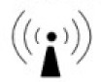
Interference may occur in the vicinity of equipment marked with the following symbol:

NOTE 1 At 80 MHz and 800 MHz, the higher frequency range applies.
NOTE 2 These guidelines may not apply in all situations. Electromagnetic propagation is affected by absorption and reflection from structures, objects and people.
a. Field strengths from fixed transmitters, such as base stations for radio (cellular/cordless) telephones and land mobile radios, amateur radio, AM and FM radio broadcast and TV broadcast cannot be predicted theoretically with accuracy. To assess the electromagnetic environment due to fixed RF transmitters, an electromagnetic site survey should be considered. If the measured filed strength in the location in which the device is used exceeds the applicable RF compliance level above, the device should be observed to verify normal operations. If abnormal performance is observed, additional measures may be necessary, such as reorienting or relocating the device.
b. Over the frequency range 150 kHz to 80 MHz, filed strengths should be less than [V1] V/m.

Annex: 4
Recommended separation distances between portable and mobile RF communications equipment and the device
Video intubation set is intended for use in an environment in which radiated RF disturbances are controlled. The customer or the user of the device can be help prevent electromagnetic interference by maintaining a minimum distance between portable and mobile RF communications equipment(transmitters) and the device as recommended below, according to the maximum output power to the communications equipment.
Rated maximum output power of transmitter (W) | Separation distance according to frequency of transmitter(m)
Rated maximum output power of transmitter (W) | 150 kHz ～ 80MHz  d = [3.5/V1]$\sqrt{p}$ | 80 MHz ～ 800 MHz  d =$1\text{.}2\sqrt{P}$ | 800 MHz～2.5 GHz  d = $2\text{.}3\sqrt{P}$
0.01 | NA | 0.12 | 0.23
0.1 | NA | 0.38 | 0.73
1 | NA | 1.2 | 2.3
10 | NA | 3.8 | 7.3
100 | NA | 12 | 23
For transmitters rated at a maximum output power not listed above, the recommended separation distance d in metres (m) can be estimated using the equation applicable to the frequency of the transmitter, where P is the maximum output power rating of the transmitter in watts (W) according to the transmitter manufacturer.
NOTE 1 At 80 MHz and 800 MHz, the separation distance for the higher frequency range applies.
NOTE 2 These guidelines may not apply in all situations. Electromagnetic propagation is affected by absorption and reflection from structures, objects and people.

Warranty
We warrant that the following products will be free from defects in material and workmanship for：
●Rechargeable Screen Handle：1 year from the date of shipment.
●Flexible Video Intubation Stylet：1 year from the date of shipment.
●During the designated period, we will, at our option, repair or replace
any parts or the product found to be defective free of change only if.
● Service, repair, or modification is carried out by us or any personnel authorized by us.
● Our products are used in proper manner in strict compliance with operating instructions.

